
ASSIGNMENT

WORKSHEET 2 SQL

Q1 to Q13 have only one correct answer. Choose the correct option to answer your question.

- Which of the following constraint requires that there should not be duplicate entries?

A) No Duplicity B) Different
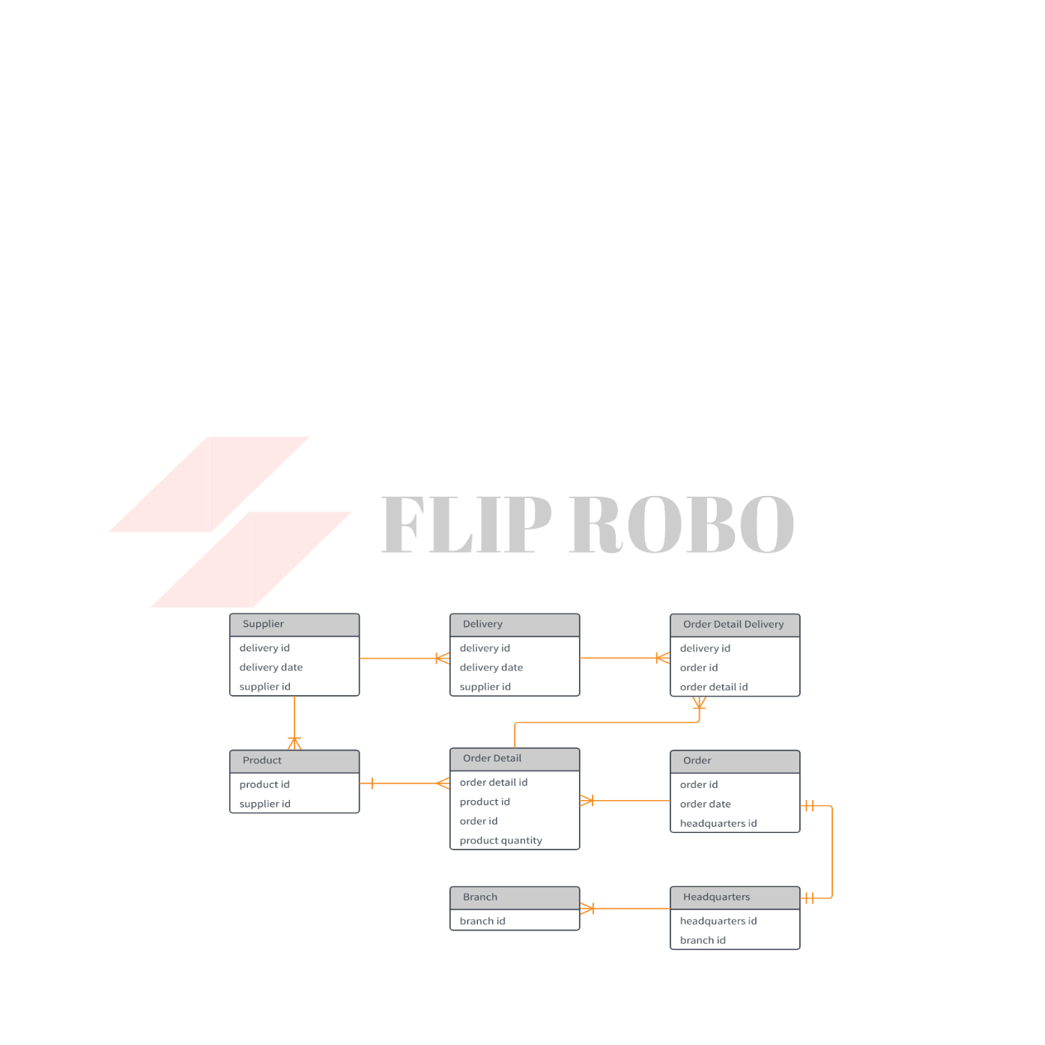

C) Null D) Unique

- Which of the following constraint allows null values in a column?

A) Primary key B) Empty Value

C) Null D) None of them

- Which of the following statements are true regarding Primary Key?

  - Each entry in the primary key uniquely identifies each entry or row in the table

    - There can be duplicate values in a primary key column

    - There can be null values in Primary key

    - None of the above.

- Which of the following statements are true regarding Unique Key?

  - There should not be any duplicate entries

  - Null values are not allowed

  - Multiple columns can make a single unique key together

  - All of the above

- Which of the following is/are example of referential constraint?

A) Not Null B) Foreign Key

C) Referential key D) All of them

For Questions 6-13 refer to the below diagram and answer the questions:

- How many foreign keys are there in the Supplier table?

A) 0 | B) 3
C) 2 | D) 1

- The type of relationship between Supplier table and Product table is:

A) one to many B) many to one

C) one to one D) many to many

- The type of relationship between Order table and Headquarter table is:

A) one to many B) many to one

C) one to one D) many to many
- Which of the following is a foreign key in Delivery table?

A) delivery id B) supplier id C) delivery date D) None of them

- The number of foreign keys in order details is:

A) 0 | B) 1
C) 3 | D) 2

- The type of relationship between Order Detail table and Product table is:

A) one to many B) many to one C) one to one D) many to many

- DDL statements perform operation on which of the following database objects?

A) Rows of table B) Columns of table C) Table D) None of them

- Which of the following statement is used to enter rows in a table?

A) Insert in to B) Update

C) Enter into D) Set Row

Q14 and Q15 have one or more correct answer. Choose all the correct option to answer your question.

- Which of the following is/are entity constraints in SQL?

A) Duplicate B) Unique

C) Primary Key D) Null

- Which of the following statements is an example of semantic Constraint?

  - A blood group can contain one of the following values - A, B, AB and O.

  - A blood group can only contain characters

  - A blood group cannot have null values

  - Two or more donors can have same blood group

